**Name: Kothinti Adarsh Reddy student id: 12597553**

**PDS Assignment-1**

Question 1:

The reproductive work flow has three stages

Stage1: Data Collection: It can be done using available source, web scraping and so on.

Stage2: Data Processing or cleaning: To compare data and assign values to entries with null values or no data present, we must first examine the data to see whether there are any elements that are different from the other data.

Stage3: Data Analysis: To form a hypothesis or reach any conclusion, we must look for distinctive components in the data, examine the available data, and plot or visually represent the data.

All the above methods have been performed on the given data below.

Raw Data:

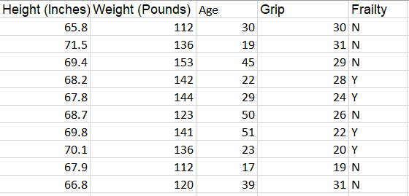

Cleaned data with BMI Index:

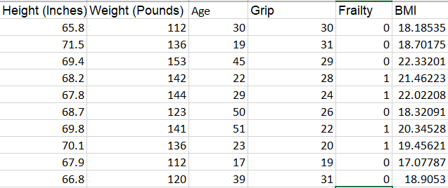

Line chart

In the above chart given is between Height and BMI and as the Height varies with the BMI

Clustered Column chart

In the above chart given is between Weight and BMI and as the Weight increases the BMI increases

Clustered Bar Chart

In the above chart given is between Age and BMI and the BMI varies with the Age

Question 2:

The reproductive work flow has three stages

Stage1: Data Collection: It can be done using available source, web scraping and so on.

Stage2: Data Processing or cleaning: To compare data and assign values to entries with null values or no data present, we must first examine the data to see whether there are any elements that are different from the other data.

Stage3: Data Analysis: To form a hypothesis or reach any conclusion, we must look for distinctive components in the data, examine the available data, and plot or visually represent the data.

Workflow:

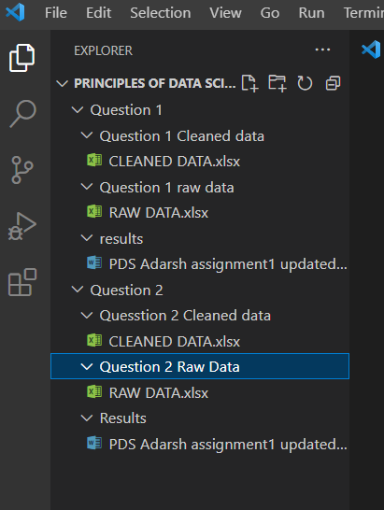

Raw data

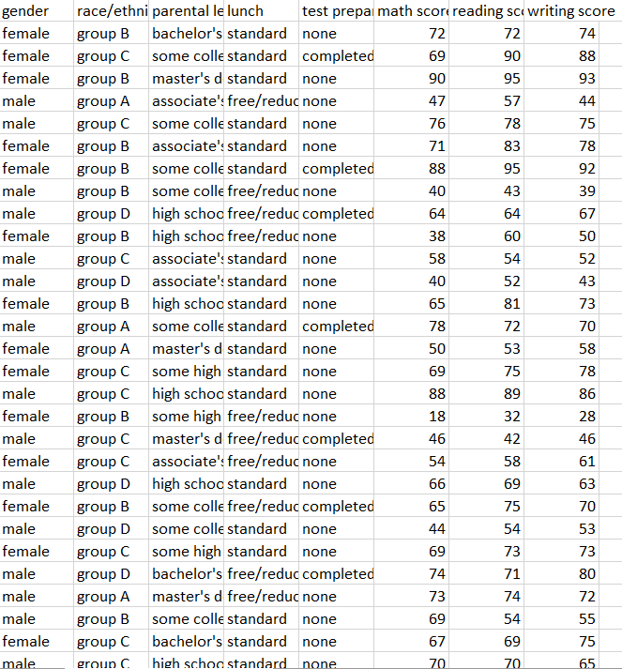

Cleaned Data

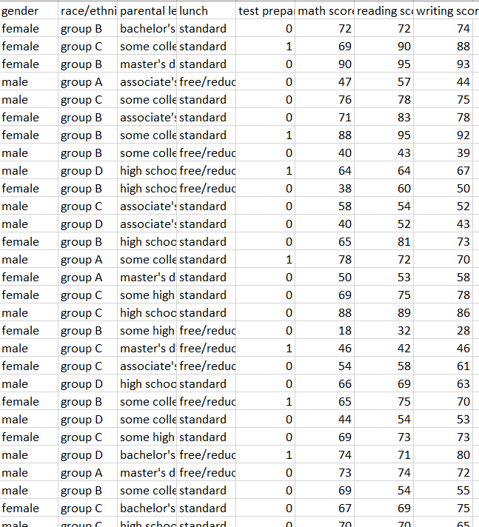

Clustered Column

This chart shows the 2 Genders having total math score

Box and Whisker

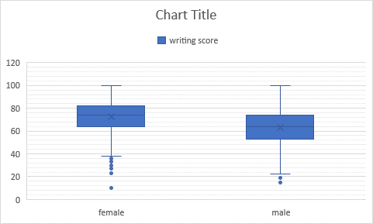

This chart shows about the genders having there writing score

Clustered Bar

This chart shows about the parental level of education and the lunch in each education level

Scatter Plot

This chart shows the comparison of reading score and gender

Clustered Column

The above chart represents the total marks scored by each race or ethnicity